Rules and Regulations of the Smart Car Race India 2010

All racing teams should use the car model and hardware distributed by Freescale Semiconductor, using S12X Microcontroller from Freescale Semiconductor as the controller. They should design control scheme and develop control algorithm in software.

Pre-final at Indian Institute of Science (IISc) will be conducted to qualify for the final racing. Place in the final competition of each racing team will be determined primarily based on time taken by each racing car to finish the racing on the designated racing track, meanwhile taking technical report and quality of development will be taken into account.

The committee of the event stipulated the following racing rules for the preliminary round and the final competition. The committee will invite Independent judges to supervise the racing on site as well as the rank judgment process.

I. Requirements on Equipment

1. Car model distributed by Freescale Semiconductor should be used.
2. S12X processor hardware and sensor distributed by Freescale Semiconductor should be used.
4. Miscellaneous
- If any component of the car model that is not allowed to change is damaged, then replacement part of the same model should be used;
.
II. Stipulations Related with Racing Track

1. Refer to Annexure - 3 for basic parameters of the racing track (excluding number of corners, location and overall layout);
2. Actual layout of the racing track will be published on the competition day.

III. Referee and Technical Judgment

The entire racing event is divided into two phases: preliminary and the final competition. The preliminary and the final competition should be carried out by IISc under direction of the organizing committee of the event. The IISc should set up a Racing Executive Committee with subordinate technical group, referee group and arbitration committee to solve various issues encountered during the racing. Workers of the organizing committee of the event, including workers from technical judgment and referee, should not participate in coaching or training for any specific racing team (except for microcontroller training) and should not disclose any information that might compromise fairness of the competition. In preliminary, referee and technical judgment method should be determined by the organizing committee in accordance with the above stipulations for the final.

IV. Racing Rules for Preliminary and the Final

Preliminary and the final competition use same racing rules. Racing teams of each group will be ranked separately.

- Rules for Preliminary Competition

- Two trial runs will be allowed to tune the parameters of racing car system
- There will be one racing track in the racing field.
- The racing teams racing order will be determined by drawing lot.
- In each racing round, each racing will run for two laps on the racing track. Time will be calculated when the racing car leaves the starting line. After running for two laps, racing cars should stop within the racing track in 3 meters after the starting line. Otherwise, 1 second will be added to the racing time of the car.
- Shorter time taken for a single lap will be calculated as the time for that round. The shortest time of the two rounds will be taken as the final time of the racing car.
- Based on number of participating teams, the organizing committee of the event will select certain percentage of racing teams to participate the final based on their scores in preliminary.
- The technical judgment group will perform on-site technical inspection for all the wining cars eligible for the final. Qualification for final of racing car that are not compliant with related equipment requirements (article 1 of the rule) will be cancelled and replaced by the next car;
- List of finalists will be submitted by the referee group to the organizing committee of the event for approval and announcement.
- After preliminary, car prototype and software can be improved (compliant with competition rules) but changes should be reported in the Technical Update Sheet.

2. Rules for Final Competition

- Two trial runs will be allowed to tune the parameters of racing car system
- The racing teams eligible for the final will be ordered based on their scores in preliminary and compete in reverse order of their scores in preliminary.
- The racing track for the final is different from that used for preliminary in shape and will be larger
- Each finalist can only compete for one time.
- Each racing will run for two laps on the racing track. Time will be calculated when the racing car leaves the starting line. After running for two laps, racing cars should stop within the racing track in 3 meters after the starting line. Otherwise, 1 second will be added to the racing time of the car.
- The shortest time taken to run a single lap will be taken as the final time of the racing car.
- Score in the preliminary will not be included in score of the final; instead, it is used only to determine racing order in final. For racing teams failed to participate or appear in time in the final will be disqualified from the final.

V. Rules for Racing Procedure

Referee will direct all the racing teams enter the playing field in accordance with the racing order. There should be only one team on the playing field at any given time. After being called by the referee, each racing team should designate a member to take their racing car to the playing field and place it in the starting area of the racing track. After the referee announces starting of the racing, the racing car should leave the starting area within 30 seconds and run for two laps continuously. After the racing car finishes the racing (2 laps), a member of the corresponding team should take the racing away from the playing field and hand it to the Jury Committee to perform Technical Inspection.

After successful competition, a screen will display the best time for a single lap. Rules for Fouls and Failure During the racing, the on-site referee will judge whether the racing car run out of the racing track according to applicable rules. After the racing car runs out of the track for the first two times, the referee should pick the car model up and hand it to the player to start the racing again from the starting area and score of the current lap will be considered invalid. Alternatively, the player can also give up the racing after his/her car runs out of the track.

Any of the following conditions will be considered as running out of the time:

- The racing team fails to enter the playing field and get prepared for the racing in 1 minute and 30 seconds after being called by the referee;
- The racing car fails to leave the starting area within 30 seconds after beginning of the racing;
- The team member can rearrange the car during the race, only if the referee gives consent and time will not be stopped.

Any of the following conditions will be considered as failure in the racing:

- The racing car runs out of the track for more than two times;
- The player touches the racing car after beginning of the racing without consent of the referee;
- The racing car fails to pass the technical inspection after the race.
- No score will be given for a failed team.

Forbidden Behaviors:

- No auxiliary lighting equipment or other auxiliary sensors are allowed around the racing track;
- After entering the playing field, players cannot modify any hardware and software except for changing battery;
- Only referee and 1 player are allowed in the playing field;
- Any behavior that might interfere with movement of the racing car is not allowed;
- No copying is allowed in the algorithm and software used in the car. Software Used in the car models of different teams of same university should be different clearly.

Inspection and Display:

- Before commence of normal racing, each racing team can test the racing environment on site.
- Before actual competition, all car models will be collected and placed in a same area by the organizing committee until end of the competition. In this course, racing teams are not allowed to modify software and hardware of the car model.
- During the racing, technical group of the organizing committee will perform technical inspection for all car models participating in the competition. In the event of any violations, the organizing committee is entitled to cancel qualification of corresponding team.

Miscellaneous:

- Racing qualification will be cancelled for any other cheating behavior during the competition;
- The rules should be interpreted by the secretariat and the organizing committee of the event.

Annexure 1: Requirements on Intelligent Racing Car Model

- It is not allowed to change structure of the chassis, distance between wheels, radius of wheel and tire;
- It is not allowed to change the components provided in the car kit.
- It is not allowed to change drive motor and battery, the car model has to be powered by the DC motor and battery of the car model itself;
- It is not allowed to change hardware provided
- It is not allowed add any extra components

Annexure 2: Basic Parameters of the Racing Track (excluding number of corners, location and overall layout)

- Surface of the racing track will use base material suitable for racing.
- Width of the racing track will not be less than 60 cms. Area of the racing track can be increased during the final.
- Specific specification for material used for surface of the racing track will be provided on web site of the event
- Surface of the racing track is white, with continuous black line (25 mms wide) drawn in the middle as the pilot line
- The minimum bending radius of the racing track will not be less than 60 cms
- The racing track can intersect with a crossing angle of 90°
- There is a starting area of 1 mt long in the racing track, as shown in figure below. In addition, there is a black starting line 10 cms long at both side of the starting point. Start time and end time should be determined when front part of the racing car passes the starting line.

2.5cm
2.5cm

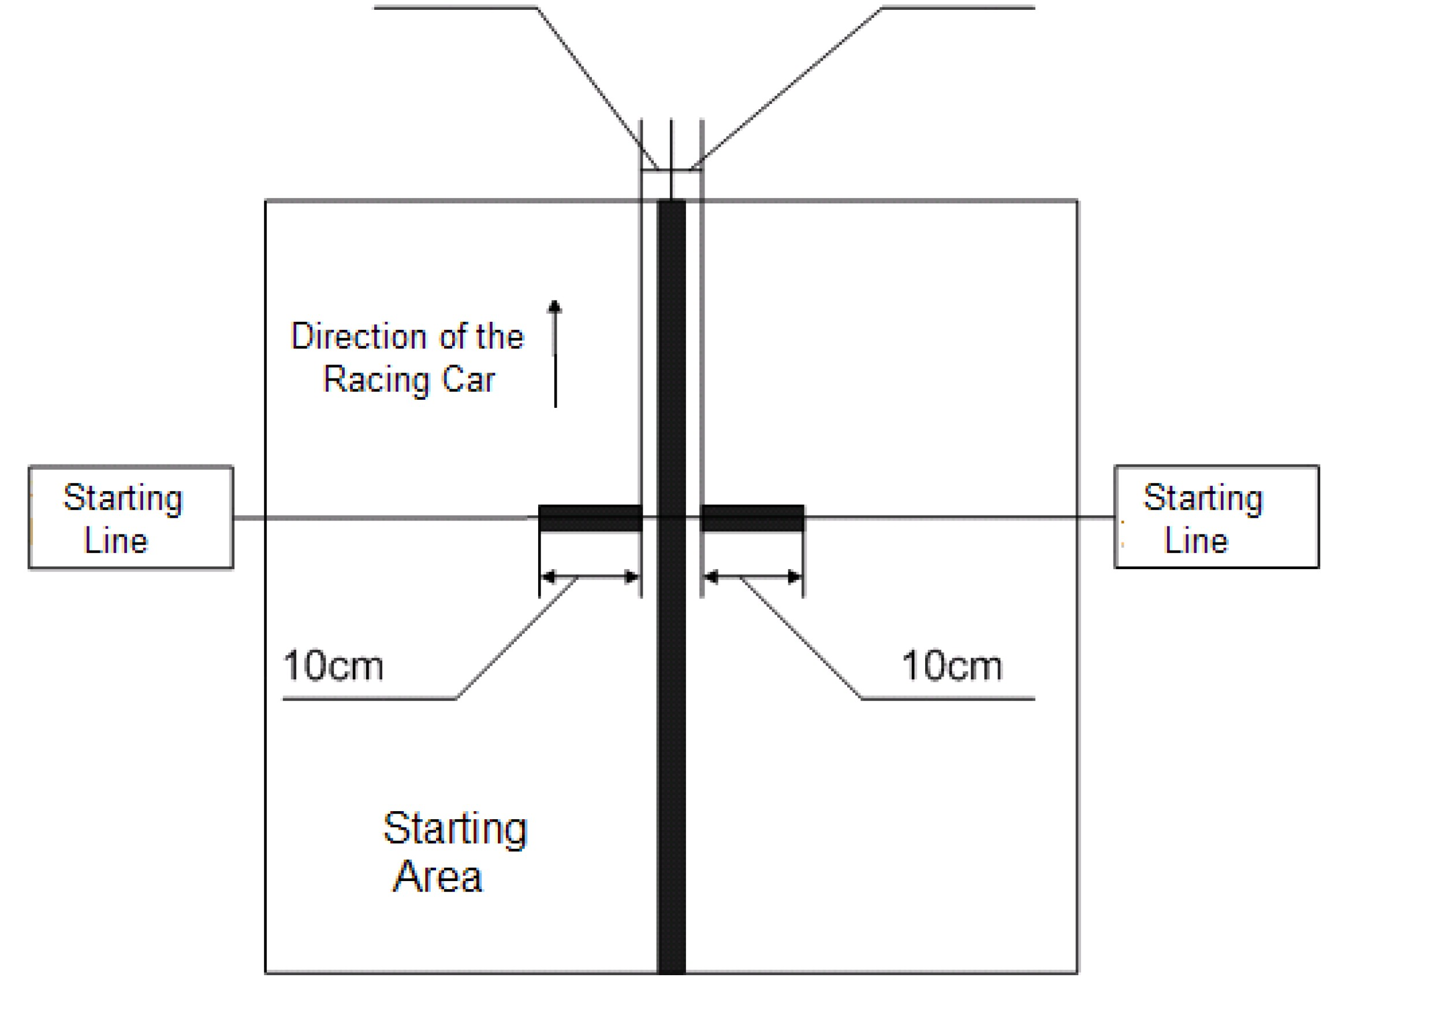
** The rules and conditions are subject to change by Freescale if necessary. Freescale reserves the right in their sole discretion to cancel, suspend and/or modify the Smart Car Race at any time.

---------------------------

